(Approx. 969 words)

OneNote serves as a computerized memory
Review of OneNote meeting presentation
By John Weigle, Editor, Channel Islands PCUG, CA
June 2015 issue, The Outer Edge
www.cipcug.org
Jweigle (at) vcnet.com

OneNote is the perfect place to keep all that information you want to remember and find easily when you need it, Toby Scott said at the May meeting. “It still is the greatest piece of software ever written,” Scott said, even though at first it doesn’t seem like much.

Because it’s “ideal for storing random data,” and because we all have a lot of that, “the longer you use it, the more valuable they (the OneNote entries) are.”

“It’s a hugely useful program, but it’s only useful if you use it,” Scott added.

OneNote started as a paid part of Microsoft Office, but it is now a free tool available for Windows, Macs, iOS (iPhone and iPad) and Android. It can be downloaded at https://www.onenote.com. The link is at the top right corner of the page.
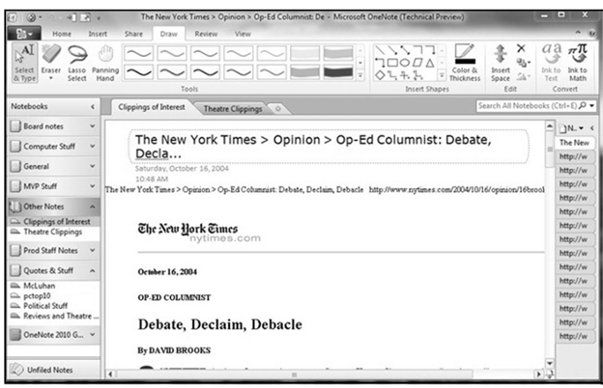
OneNote is designed to resemble school notebooks on your computer and in the cloud. It’s set up in three organizational trees, documents, sections and pages, and that layout makes it easy to store material by topics. But its search engine is so good that users can put material anywhere in the program, and it will be easy to find, he said.

Scott recommends keeping the notebooks in Microsoft’s OneDrive so they’ll be available on any device wherever you are. Among other things, he keeps articles and websites that he finds on how to fix unusual computer problems.

But that’s just one possibility, he said. When he was planning a trip to Utah, he stored Web pages and other information about the state, including places he might want to visit. When you copy text or pictures from a website and paste it into OneNote, it automatically adds a link back to the source. The link is clickable, so it’s easy to return to original information sources.

Users can add material to OneNote with copy and paste, drag and drop and “send to.” Tools for Firefox and Chrome browsers let users save full Web pages to OneNote.

Users can insert Excel spreadsheets and PowerPoint presentations or links to them in the program.

OneNote has optical character recognition abilities so its search function can find text in pictures and graphics. Scott demonstrated that by taking a screen shot of a DOS screen, putting it in OneNote and searching for a word that was in the graphic. The word was highlighted each time it appeared.

Skype calls can also be recorded and saved in OneNote, as can emails. Templates for other Office programs work in OneNote. Notebooks, sections and pages can be password-protected and shared with other people.

Asked how OneNote and Evernote compare, Scott said that Evernote was developed as a free alternative to OneNote, which cost about $150 when it was first released. Scott said it’s best to use one or the other, but not both, because they can’t open each other’s files.

Although Scott knew about OneNote, he didn’t start using it until a speaker at an Intel conference used it to find an answer to an attendee’s question. The speaker didn’t recall the answer but had it stored in OneNote and found it easily. When most of those attending asked about the program he used to find the answer, the speaker quickly wrapped up his Intel presentation and demonstrated OneNote, calling it “the only way to keep track of all this stuff.”

Asked how OneNote compares to Dropbox, Scott said they’re entirely different.

OneNote is a program, while Dropbox is a cloud storage system like Microsoft’s OneDrive and Google’s Google drive. Don’t confuse the storage media with the program that stores the data, he advised.

Another person asked about calendars in One Note. OneNote has a weak calendar function, Scott said, but you can’t store a calendar in it that provides repeating events and similar tools. There are third-party templates that work quite well. Many are for special situations, so you need to figure out what you need. Calendars are persnickety, he added.

For things like calendars, mail and contacts, “you pretty much have to settle on one platform, he said, and he prefers Outlook, also part of Microsoft Office.

People can use the cloud to synchronize or back up various devices, but they don’t need to store everything in several cloud storage sites. Because of size limits, however, some people might find it easier to store photos in one location, music and video in another and other data in a third. That all depends on how much data is involved, he explained.

If a device that has OneDrive access — such as a laptop — is lost or stolen, Scott said, he can go to OneDrive and block its access to the device. At the OneDrive website login screen, highlight the device, and click on Remove PC. Users should also enable two-factor identification so that any new device that logs into your OneDrive has to be authenticated by entering a code that Microsoft sends to your primary device, he added.
In this way, a hacker who discovers you username and password still cannot get to your data.

An audience member asked if it’s possible to stop Android devices from backing up photos before she gets a chance to delete ones she doesn’t want. The answer is to go to the Photo App in settings and change the auto backup settings.

An audience member noted that a spreadsheet that was cut and pasted into OneNote loses its functionality. Another member of the audience asked if there’s a good tutorial for OneNote. Scott said there are many videos on YouTube and written material on other sites, but they’re not needed. The best way to learn OneNote is to start using it.

